Technical Datasheet Sensor Modules with Modbus RTU Protocol with RS485 Interface

The Sensor modules communicate via RS485. The port can drive distances up to max 700 meters without the use of any repeater (this feature however also depends on the signal strength of the Modbus Master Device).
The RS485 Digital Sensor module is sturdy, low power usage and easy to use.

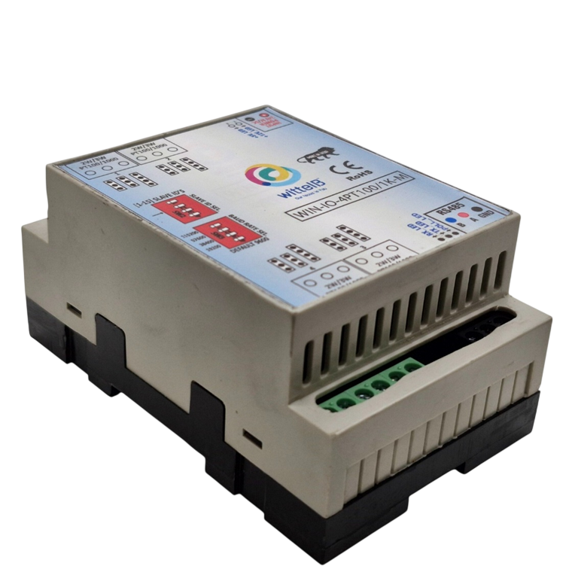
PT100/1000 Module: -

The Sensor modules are mounted on DIN rail mountable casing and with exposed connectors and LED indicators. The DIP switch for Slave ID and Baud rate are placed inside the enclosure.
Handles 100Ω to 1kΩ (at 0°C) Platinum RTDs (PT100 & PT1000), Compatible with 2-, and 3-Wire Sensor Connections.
The design of the modules incorporates ‘resettable Fuses’ to safeguard against reverse polarity connection both for Power and Communication port.

Specifications
General –
Connectors |  | 2 Pin 5.08 mm pitch pluggable screw terminals.
Dimensions |  | 70 mm L x 110 mm B x 50 mm H
Power |  | Input Power – 12 – 24 VDC or 24 V AC/DC
Typical – 12V DC @ 80mA
Operating Temperature 0 – 60 °C (32 ~ 140F)
Storage Temperature -20 - 70 °C (-4 ~ 158F)
Storage Humidity |  | 5 ~ 95 % RH, non – Condensing
Certifications  AI Inputs –  Channels  Input Signal |  |   4  4 – PT100 / PT1000 – 10 V (jumper selectable)-Two
wire/Three wire
Accuracy Total Accuracy over All Operating Conditions: 0.5NC
(0.05% of Full Scale) max.

Input Resolution 15-Bit ADC Resolution.
Isolation Optically Isolated.

Additional Features: -

All inputs and communication ports isolated
Input power reverse polarity safety
ESD Safety IEC 61000-4-2,  30KV contact,  30KV air EFT IEC 61000-4-4, 50A (5/50ms) 750V isolation.
CRC Error check.
No configuration needed on the IO board

Configuration Settings: -
Communication Speed 9600 – 19200 Kbps (DIP SW Selectable)
Data Bits 8
Parity None
Stop bit 1
CRC Yes
Slave ID Configurable with DIP Switch Function Code 0x03 Read Holding Registers
AI Register Address 0,1,2,3.

ID | Function Description | Register Description | Modbus  Function Code | Protocol | Data Type
0 | RTD1 | 40001 | 0X03 | RS485 | 16 Bit Unsigned int
1 | RTD2 | 40002 | 0X03 | RS485 | 16 Bit Unsigned int
2 | RTD3 | 40003 | 0X03 | RS485 | 16 Bit Unsigned int
3 | RTD4 | 40004 | 0X03 | RS485 | 16 Bit Unsigned int

2&3 wire Connections : -

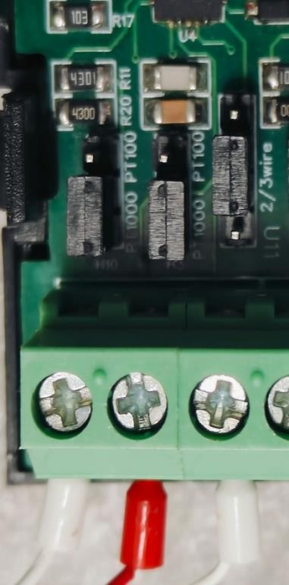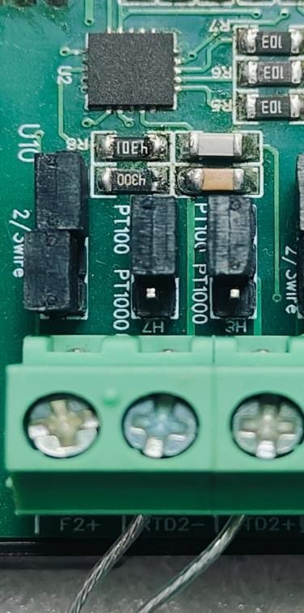
3 wire connection 2 Wire connection
Recommended Cable Electrical Characteristics: -
22 AWG Cable Shielded and twisted pair should be used.
Tinned Copper Recommended
Nominal Conductor DCR 14.7 ohm / 1000 ft
Nominal Capacitance 11 pf / feet (conductor to conductor)
High Frequency Non-Insertion Loss 0.5db / 100ft

BAUD RATE DESCRIPTION

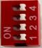

L
SB

M
SB

- For Baud rate Selection, DIP SW is used as per the diagram.
- Pulling up the switch will make Baud rate active.
- If no selection is made 9600 will be default Baud rate.
- When u change the Baud rate in the Module power ‘ON’ condition,
please press the reset button to get Change to affect.

Baud Rate |  | DI | P SWITCH
 | 1 | 2 | 3 | 4
9600 | OFF | OFF | OFF | OFF
19200 | ON | OFF | OFF | OFF
38400 | OFF | ON | OFF | OFF
57600 | OFF | OFF | ON | OFF
115200 | OFF | OFF | OFF | ON

SLAVE ID DESCRIPTION



MSB

LSB

- For Slave ID Selection SW is used to Set The SLAVE ID .
- For Slave ID DIP Switch LSB is “1” follow through “4” is MSB.
- Slave ID Confirmed through below Device ID table .
- IF Eg. Slave ID 1 is Needed to be selected Switch number 1 should pulled up other three should be selected down side. So”1 0 0 0” will be selected as Slave ID 1.

Slave ID |  | DIP SWITCH |  |  | OUTPUT  (Binary) | OUTPUT  (Decimal)
 | 1 | 2 | 3 | 4
0 | OFF(0) | OFF(0) | OFF(0) | OFF(0) | 0 0 0 1 | 1
1 | ON(1) | OFF(0) | OFF(0) | OFF(0) | 0 0 0 1 | 1
2 | OFF(0) | ON(1) | OFF(0) | OFF(0) | 0 0 1 0 | 2
3 | ON(1) | ON(1) | OFF(0) | OFF(0) | 0 0 1 1 | 3
4 | OFF(0) | OFF(0) | ON(1) | OFF(0) | 0 1 0 0 | 4
5 | ON(1) | OFF(0) | ON(1) | OFF(0) | 0 1 0 1 | 5
6 | OFF(0) | ON(1) | ON(1) | OFF(0) | 0 1 1 0 | 6
7 | ON(1) | ON(1) | ON(1) | OFF(0) | 0 1 1 1 | 7
8 | OFF(0) | OFF(0) | OFF(0) | ON(1) | 1 0 0 0 | 8
9 | ON(1) | OFF(0) | OFF(0) | ON(1) | 1 0 0 1 | 9
10 | OFF(0) | ON(1) | OFF(0) | ON(1) | 1 0 1 0 | 10
11 | ON(1) | ON(1) | OFF(0) | ON(1) | 1 0 1 1 | 11
12 | OFF(0) | OFF(0) | ON(1) | ON(1) | 1 1 0 0 | 12
13 | ON(1) | OFF(0) | ON(1) | ON(1) | 1 1 0 1 | 13
14 | OFF(0) | ON(1) | ON(1) | ON(1) | 1 1 1 0 | 14
15 | ON(1) | ON(1) | ON(1) | ON(1) | 1 1 1 1 | 15
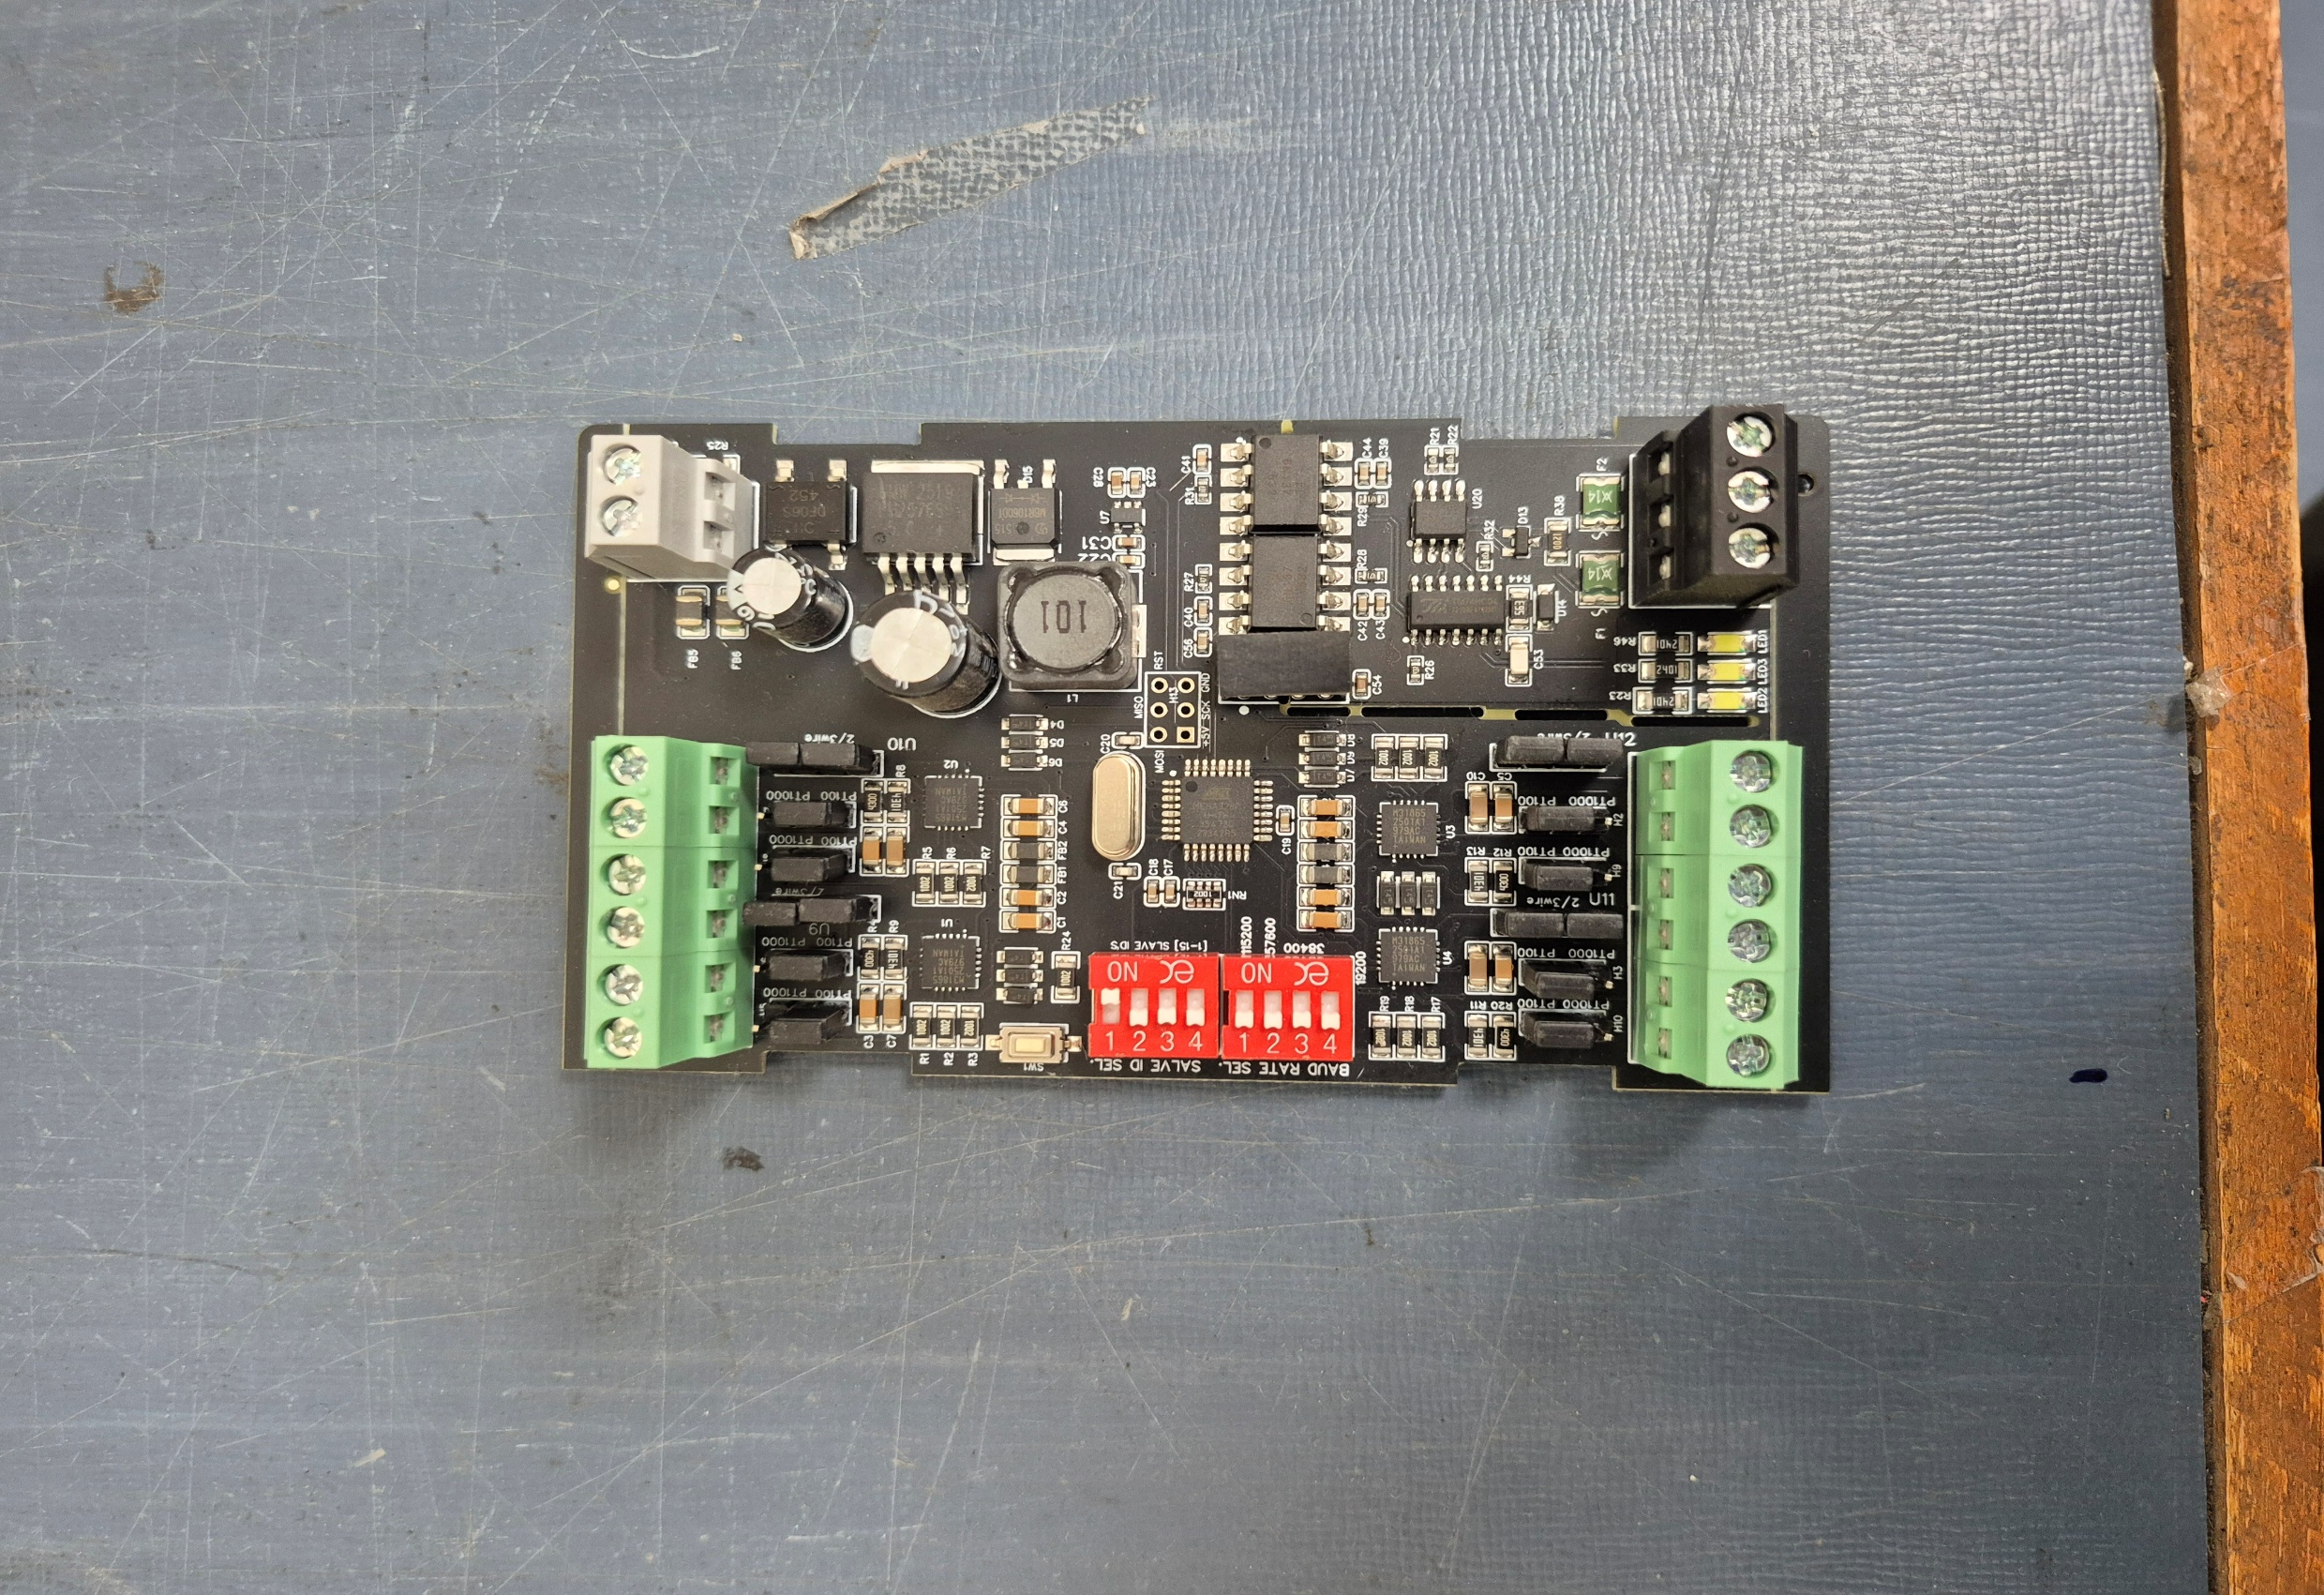









RTD4

RTD3

RTD1

RTD2

Input12
-

24
V
AC/
DC

Modbus
RS 485

Slave

ID

Baud Rate

Jumper

PT100/PT100
Jumper

2
/3
Wire

Contact us: -
Augmatic Technologies Pvt. Ltd.,
Plot no 6, Shah Industrial Estate II, Kotambi, Vadodara – 391510.
Email – Sales@wittelb.com
Support: support@wittelb.raiseaticket.com / +91 94038 92805

